MI_CARE EHEALTH MOBILE APP UI/UX DESIGN

BY
ISHMAEL ASIAGO & MULONGO DUNCAN

MI_CARE EHEALTH SERVICE
www.mi_care.org



- SPLASH SCREEN [SCREEN 0].
The first view of the mobile application presents the user with the platform’s logo and slogan. Besides serving as a marketing view, it sets the pace for the app by enabling some time for data loading and synchronization.

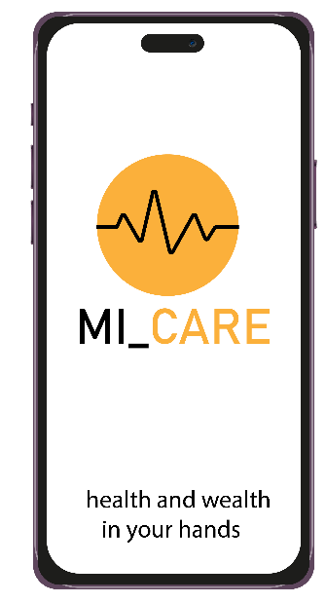

- SIGN UP [SCREEN 1].
This view lets a first-time agent choose the type of user based of how he/she intends to participate on the MI_CARE block chain.

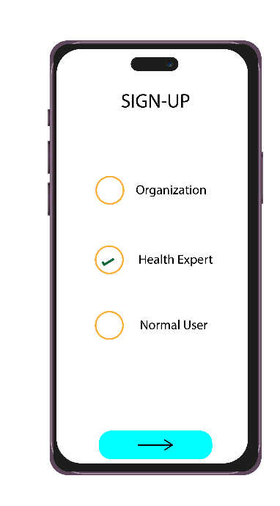
- PERSONAL DATA.
This view contains input fields; First Name (FNAME), Surname (SNAME), Phone Number (PNO), Email address (E.ADDRESS),Date of Birth (D.O.B), National ID (ID NO), Profession/Occupation (PROFF), RACE, GENDER, Genetic conditions (If any), KRA PIN, Physical Challenges (If any).
N.B this applies when an agent chooses either “Health Expert” or “Normal User”.

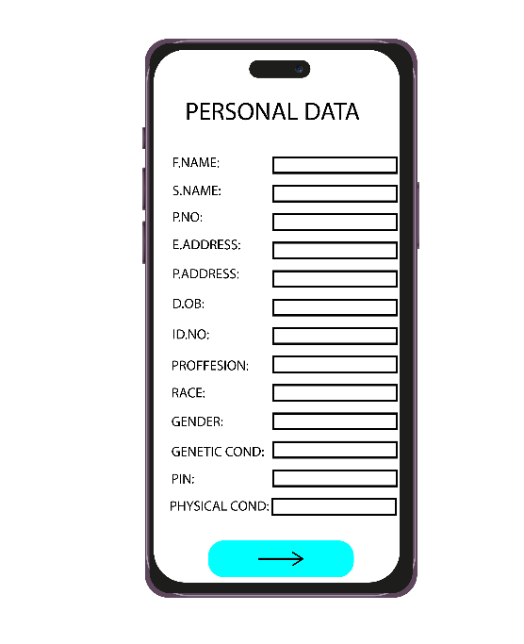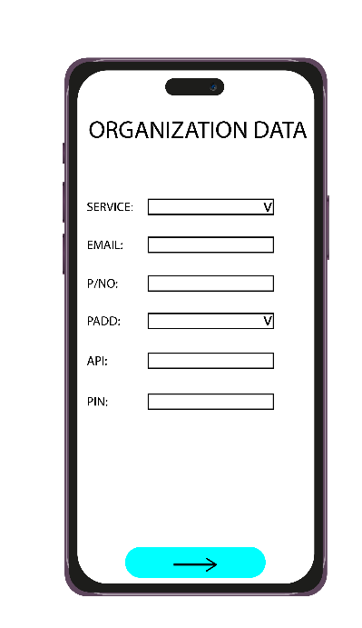

- CERTIFICATION.
This view enables agents to certify that they are whom they purport to be based on the information given above. For those with age=>18, National ID card/Passport or Alien ID will be captured otherwise, the Birth Certificate Doc will be captured. D.O.Bs on the certification documents will be checked if they match and/or are consisted with the data provided in (3); Names, Physical Address, D.O.B, IDs and/or Registration Numbers.

The same will apply to KRA certificate and professions.
If an agent signs up as a Health Expert, proof of professionalism will be verified by capturing academic certificates and/or recommendation letters.

Biometrics like Passport-sized facial photo, fingerprints and Iris scans will be captures at this stage.
If an agent signs up as an organization, compliance certificates and licenses will be captured and verified.

An AI agent will be involved alongside onboard smart contracts in recognition of photo & live images, biometrics, characters and text on the documents before they are verified and later validated and or invalidated.
If an agent chooses “Organization” must proof its status confirming >5 Experts and customers (Normal user). They may do so by registering them under their organization.

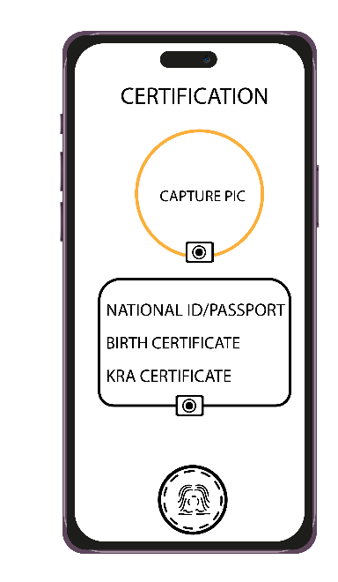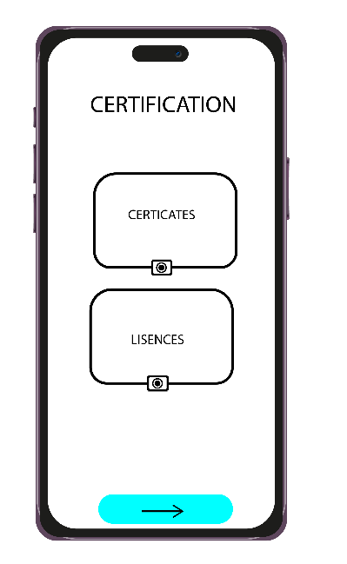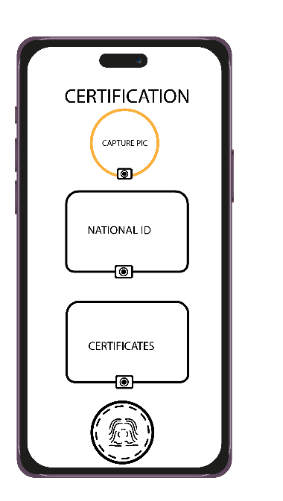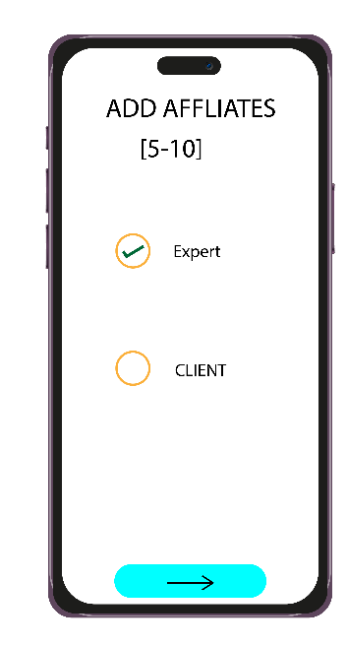

- SERVICES SELECTION.
This view enables any signing up agent to choose the type of services they want to access on the MI_CARE block chain. These will include; Gym Services, Expertise, Restaurants/clubs, Pharmaceutics, money, medical care (hospitals), Insurance, Medical Laboratory, Wearable device
Etc.

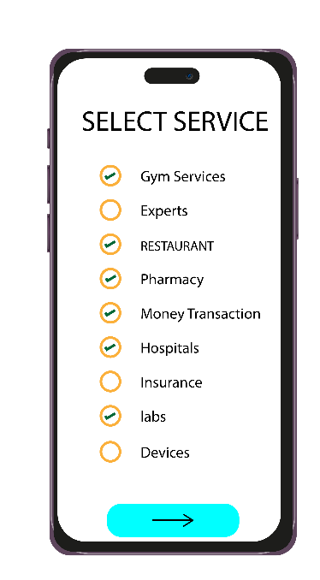

- SUBMISSION & VALIDATION.
The agent should read policy document, accept and sign before submitting the data for validation. Additional information concerning agents expected data is presented in this view.

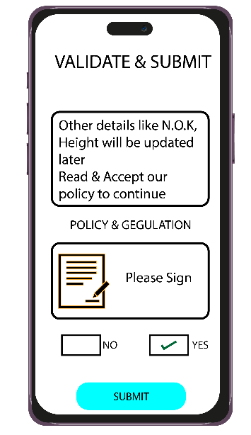

- VALIDATION STATUS.
Upon submission, the data is vetted if it meets all requirements for registration. If invalidated, the process is repeated until the desired data is obtained. Otherwise, a validation view with the message, “Your data has been validated, check your email to verify”.

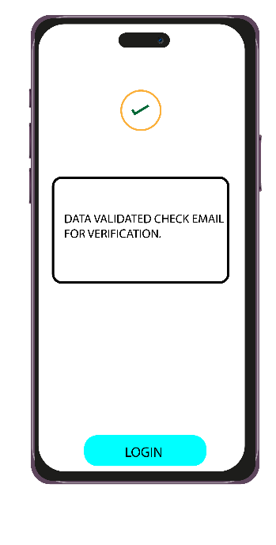

- LOGIN.
This view enables the registered user to login. A twostep verification process with two options is availed. The combination of the PIN (Personal Identification Number) and biometrics; (fingerprints/facial capture) or QR scan is used. For those whose devices lack biometrics, may scan a QR code send to their email address.

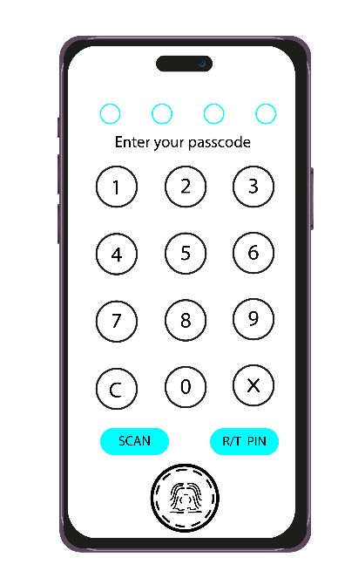

- ACCOUNT.
For a normal user, the account may contain; a side menu with: Devices, Orgs, dedicated peers, Reports, settings and logout link. Chats, search, notification bell and a rightmost three dot access to other undisclosed functionalities. All of these on the top bar.

A validation circular mark with a tick within and the user’s block chain address below it will take position below the top bar.

Below the mark will be the user’s block chain status counter and recent updates.

After the status counter will be the sect for: Health Entries, Appointments, Current medication etc.

The bottom bar will contain: Audio/Video call icon, General Updates and wallet.
For an Expert user, the account view stays the same safe for a few differences like assignments instead of appointments etc.
For organization, the account view stays the same safe for the side menu with: Services, Clients, Experts, Orgs, Settings, Reports and logout link.
The scrollable sect could contain information like: medical history, purchases, deaths etc.

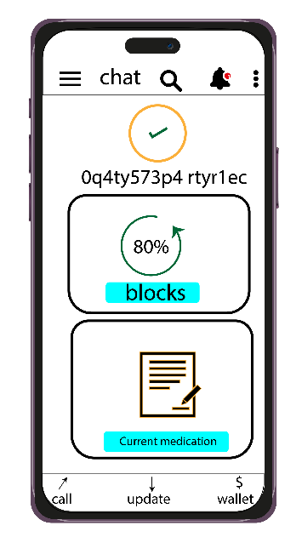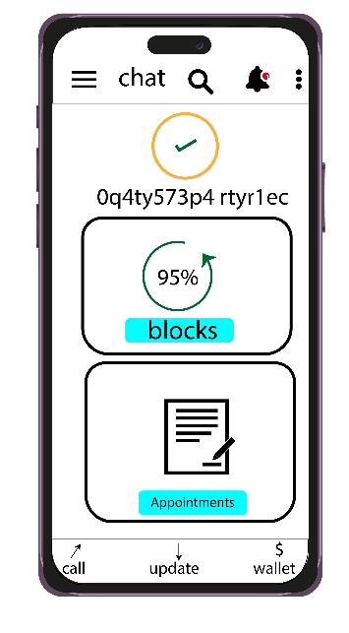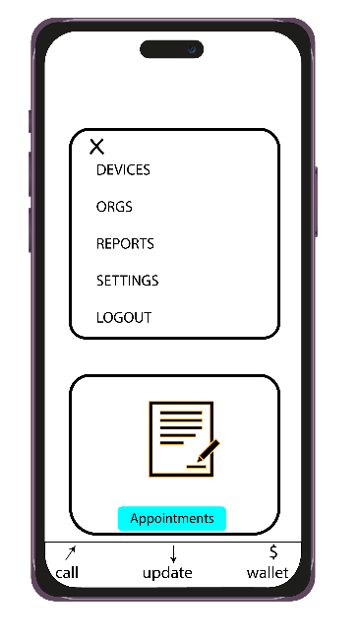
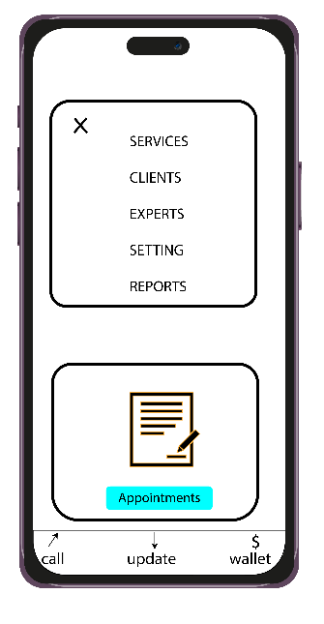

- REALTIME GEO VISUALIZER AND RESPONDER
A map tool will be provisioned for all users but the access and usage will vary. The map will show disease hotspots, emergency spots, block chain facilities each of these with an active, expandable and reply enabled message box.
Other map interaction tools like zoom, direction, type of map etc. will be provisioned.

A toggled side menu will contain an Analytics view with graphs and statistics based on: Date, physical address, Coordinates, Diseases, Organizations and type of graphs.

The bottom bar will contain clear icon, download and share icons.

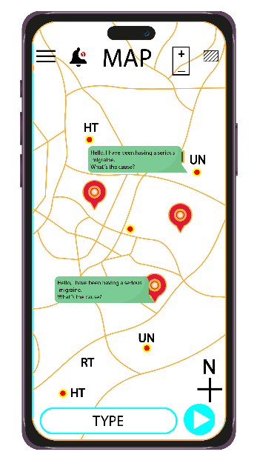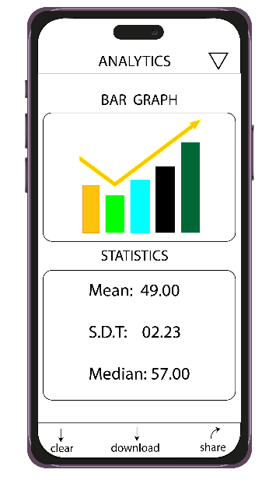

- WALLET.
This view will provide the mechanism to transact on MI_CARE block chain.
The top bar will contain: The validation mark, analytics icon, scanning icon, notification bell and rightmost menu.

Below will be account balance in HTBs and the last update time and on the side ways be the “Deposit” and “Send” buttons. The user’s block chain address will appear at the top of this section.

Below will be the transaction history details.
On the bottom will be: withdraw, pay and exchange icons.

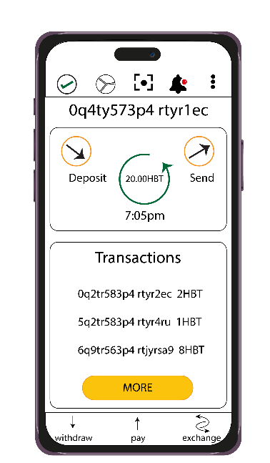

- ENGAGEMENT VIEW.
This will contain: The top menu with; Chats history, AI BOT, Updates history and Calls history and reachable address on the block chain. Scanning, Search and the rightmost menu could still appear.
The main window will populate: Updates, Chats and Calls.
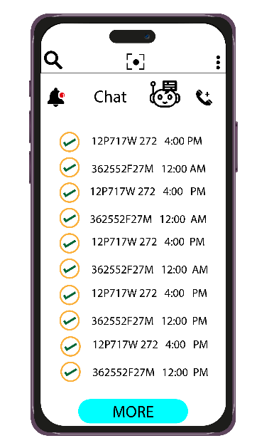

- CHAT WINDOW.
This will contain actual chats in the main window. The top menu will be same as the ENGAGEMENT VIEW.
The input will support text, coins, emoji, attachments, scans and images.
